

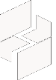

MICROSOFT ARCHITECTURE BEST PRACTICE FOR AI BUSINESS PROCESS
USECASE: MICROSOFT FOUNDRY CHAT

Document Title | Microsoft Cloud Center of Excellence Overview
Presales/Technical Head | Tushar Mehrotra/Rohit Pandey
CCoE Lead | Ravishankar N
Creation Date | 27th March 2026
Version | Description | Modified by | Date | Approved by | Date
1 | Draft architecture baseline for review | Sharmila Devi K | 24/03/2026 | Ravi Shankar | 24/03/2026
2 | Updated draft with architecture refinements and review comments | Sharmila Devi K | 27/03/2026 | Ravi Shankar | 27/03/2026
Contents

1. Executive Summary 3
2. Scope and Applicability 3
3. Business Scenario Overview 3
4. Reference Architecture Overview 4
4.1 Architecture Description 4
5. Logical Architecture Components 4
5.1 Presentation Layer 4
5.2 Orchestration and Agent Layer 5
5.3 AI Model Layer 5
5.4 Data and Grounding Layer 5
5.5 Networking and Security Layer 6
6. Architectural Best Practices 6
6.1 Azure Well-Architected Framework Alignment 6
6.2 Governance & Operations 6
6.3 Security and Responsible AI 6
7. Cloud Center of Excellence Enablement Model 7
8. Reusability and Scalability 7
9. Conclusion 7

Microsoft Foundry Chat

Executive Summary
This document defines the standardized reference architecture and architectural best practices governed by the Cloud Center of Excellence (CoE) for designing and deploying enterprise-grade conversational AI applications using Microsoft Foundry Chat on Azure.
The reference architecture is based on the Microsoft Azure Architecture Center baseline guidance, which demonstrates how to securely build, deploy, and operate AI-powered chat applications using Microsoft Foundry, Foundry Agent Service, Azure OpenAI models, and supporting Azure platform services. [learn.microsoft.com]
This document serves as audit-ready evidence of Cloud Center of Excellence capability in accordance with Frontier Distributor checklist – Section 3.1.1.

Scope and Applicability
This reference architecture applies to:
- CSP distributors enabling generative AI workloads
- Enterprise and line-of-business chat applications
- Secure, production-grade conversational AI solutions
- SMB, Mid-Market, and Enterprise customer environments
- Regional and global CSP deployment models
The architecture supports consistent, governed deployments across regions, aligning with Frontier Distributor Cloud CoE expectations.

Business Scenario Overview
- Organizations increasingly require enterprise chat applications that allow employees and customers to interact with AI agents using natural language. These chat applications must:
- Use advanced large language models (LLMs)
- Integrate securely with enterprise data sources
- Enforce governance, security, and compliance controls
- Scale reliably in production environments
Microsoft Foundry Chat provides a managed framework for building these enterprise chat solutions using Azure native services.

Reference Architecture Overview

4.1 Architecture Description
The solution implements a baseline enterprise chat architecture, consisting of:
- A secure chat user interface hosted in Azure App Service
- A persistent AI agent hosted in Foundry Agent Service
- Azure OpenAI models deployed in Microsoft Foundry
- Grounding via enterprise data stores or search services
- Private endpoint-based communication between components
This baseline architecture is designed for production readiness, security, and scalability.
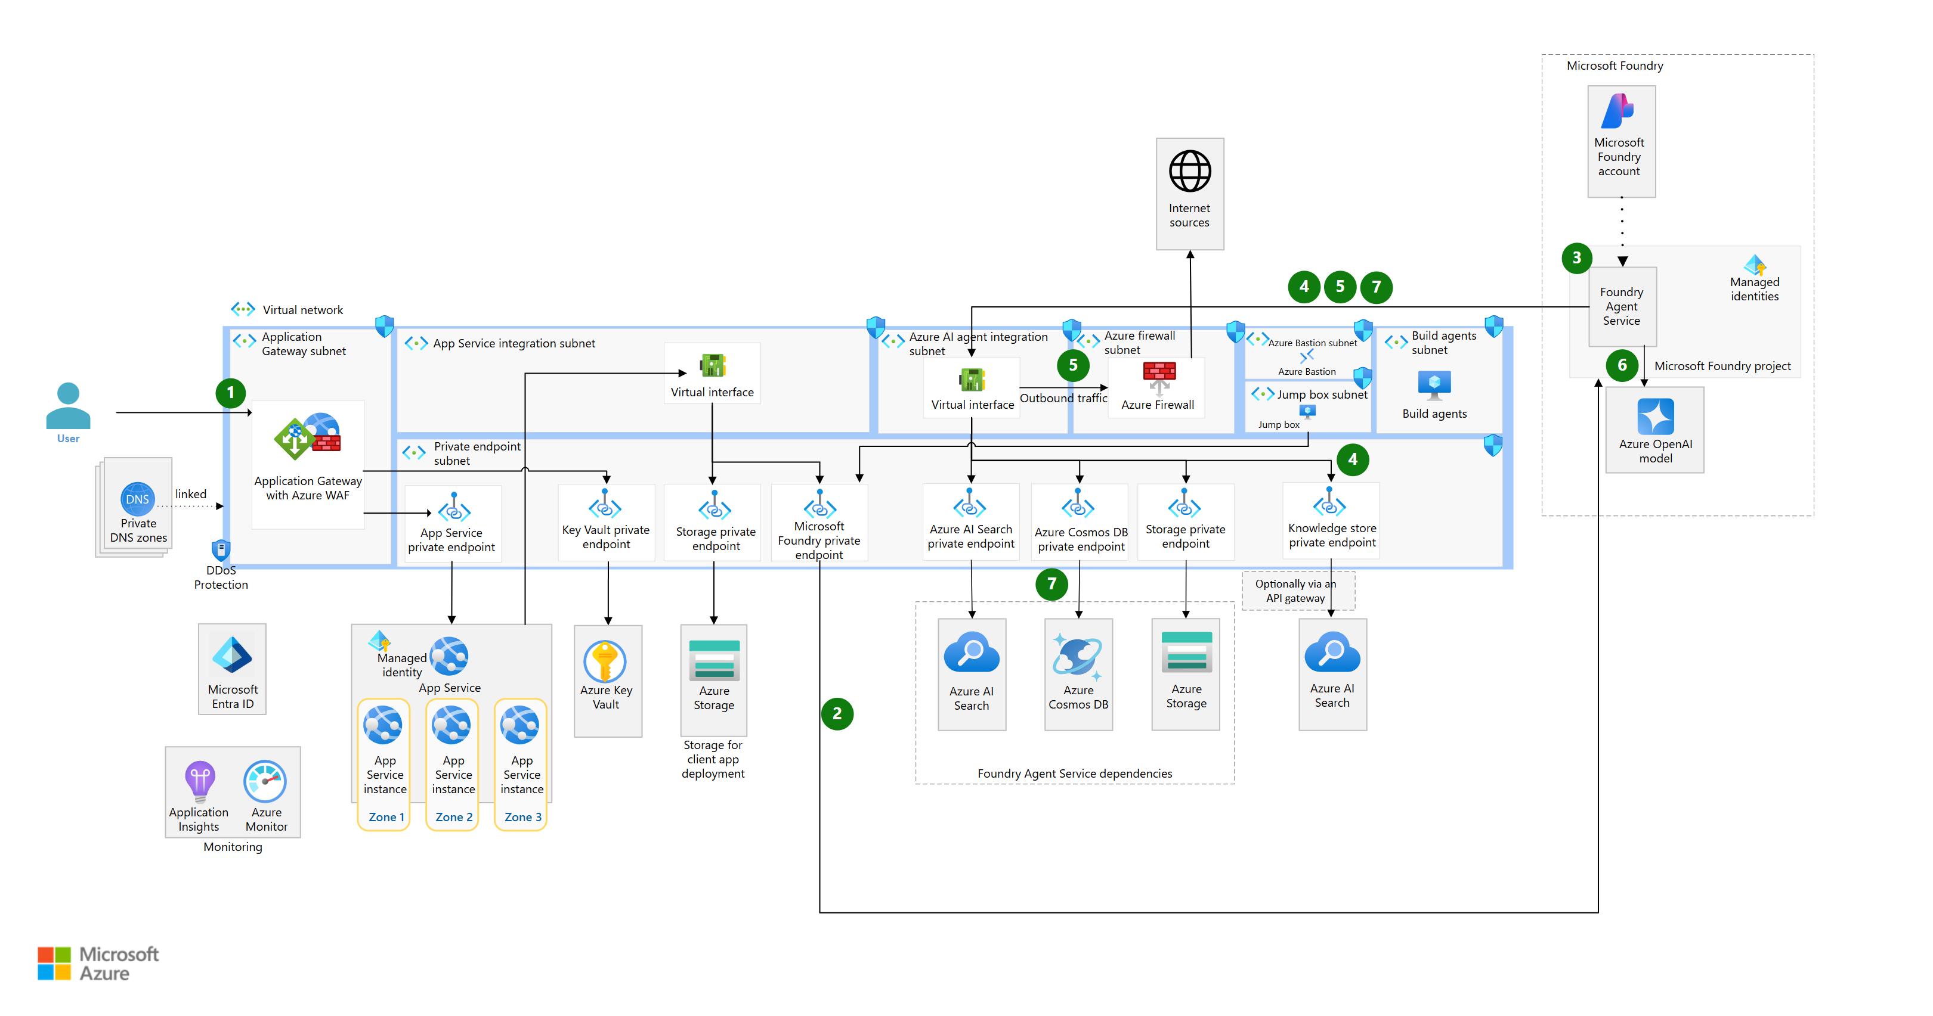

Logical Architecture Components

5.1 Presentation Layer
Chat User Interface
- Integrated into an enterprise web application
- Hosted on Azure App Service
- Supports authentication via Microsoft Entra ID
The chat UI follows Azure App Service baseline guidance for secure and highly available web applications.

5.2 Orchestration and Agent Layer
Microsoft Foundry Agent Service
- Hosts a persistent chat agent
- Orchestrates conversations between users, models, and data sources
- Maintains chat context and interaction state
The agent executes prompt workflows and augments prompts with grounding data before sending them to the language model.

5.3 AI Model Layer
Azure OpenAI Models in Microsoft Foundry
- Large language models (e.g., GPT models)
- Used for reasoning and response generation
- Deployed as managed services
These models generate responses using both user input and retrieved grounding information.

5.4 Data and Grounding Layer
Enterprise Data Source
- Azure AI Search
- Internal databases or knowledge stores
- Optional external grounding sources
Grounding ensures that responses are contextually relevant and enterprise-specific.

5.5 Networking and Security Layer
- All communication occurs over private endpoints
- Public access to Foundry portal and agents is disabled
- Outbound traffic is routed through Azure Firewall
- Virtual network integration ensures network isolation
This design enforces enterprise-grade security and compliance.

Architectural Best Practices

6.1 Azure Well-Architected Framework Alignment
Pillar | Implementation Approach
Reliability | Managed App Service and Foundry Agent Service
Security | Private endpoints, Zero-Trust networking
Performance | Scalable App Service plans
Cost Optimization | Right-sized compute and model usage
Operational Excellence | Centralized monitoring and logging
Microsoft Foundry Chat aligns with Azure Well-Architected Framework recommendations for AI workloads.

6.2 Governance & Operations
- Centralized agent definitions in Foundry
- Controlled model deployment and access
- Versioned prompt and agent logic
- Monitoring via Azure Monitor and Application Insights
These practices ensure repeatable, auditable chat deployments.

6.3 Security and Responsible AI
- Secure access via Microsoft Entra ID
- Restrictions on data access and grounding sources
- Network isolation and encrypted traffic
- Enforcement of Responsible AI usage policies
The architecture supports Microsoft Responsible AI principles through controlled AI interactions.

Cloud Center of Excellence Enablement Model
The Cloud Center of Excellence:
- Owns and governs enterprise chat reference architectures
- Maintains approved patterns for Foundry-based AI solutions
- Defines security, networking, and operational standards
- Enables resellers with reusable templates and documentation
- Ensures consistency across regions and customer engagements
This governance model satisfies the Cloud Center of Excellence requirements defined in Frontier Distributor checklist Section 3.1.1.

Reusability and Scalability
This reference architecture:
- Is reusable across enterprise chat scenarios
- Scales to support increasing user load
- Supports multi-region and through-channel deployments
- Acts as a foundation for advanced AI agents and copilots

Conclusion
This Cloud Center of Excellence reference architecture provides a Microsoft-aligned, audit-ready, and repeatable foundation for enterprise chat applications using Microsoft Foundry Chat on Azure. It enables distributors to support secure, scalable conversational AI solutions while maintaining governance, operational excellence, and architectural consistency across the partner ecosystem.

